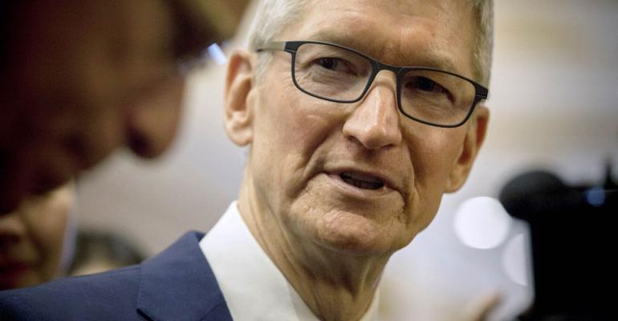

[**SECURITY**](https://www.itprotoday.com/security)**>**[**COMPLIANCE**](https://www.itprotoday.com/security/compliance)

**Apple CEO Calls for `Data-Broker Clearinghouse' in Privacy Push**

Apple Inc. Chief Executive Officer Tim Cook called on the Federal Trade Commission to track data brokers and monitor how they use people’s digital information, the latest privacy push by the iPhone maker.

[Bloomberg](https://www.itprotoday.com/author/null-Bloomberg) | Jan 17, 2019

(Bloomberg) -- Apple Inc. Chief Executive Officer Tim Cook called on the Federal Trade Commission to track data brokers and monitor how they use people’s digital information, the latest privacy push by the iPhone maker.

Cook joined other technology company executives in calling for federal privacy legislation, but added his own specific idea in a column published by Time.

"The Federal Trade Commission should establish a data-broker clearinghouse, requiring all data brokers to register, enabling consumers to track the transactions that have bundled and sold their data from place to place, and giving users the power to delete their data on demand, freely, easily and online, once and for all," Cook wrote.

Data brokers amass information about consumers from public records, various online sources and other companies and create profiles that they sell, often to target digital ads. The industry lacks transparency and Congress should consider laws giving consumers more control over personal information, the FTC said in 2014 after studying companies including Acxiom Corp., Datalogix Inc. and CoreLogic Inc.

"One of the biggest challenges in protecting privacy is that many of the violations are invisible," Cook wrote in the Time column.

When consumers buy something online, the retailer often sells or transfers information about the purchase to a data broker, which packages it and sells it on, he said.

"All of these secondary markets for your information exist in a shadow economy that’s largely unchecked -- out of sight of consumers, regulators and lawmakers," Cook wrote. "Let’s be clear: you never signed up for that."  
 <https://www.itprotoday.com/compliance/apple-ceo-calls-data-broker-clearinghouse-privacy-push>